WEBSITE VOUCHERS REDEMPTION

TAP clients may use their vouchers as form of payment to buy tickets through our official website www.flytap.com
Note: not possible to use vouchers as form of payment for reissuances or ancillaries’ purchases.

- Select and book a flight

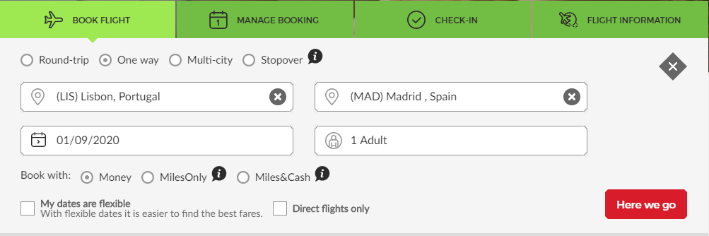
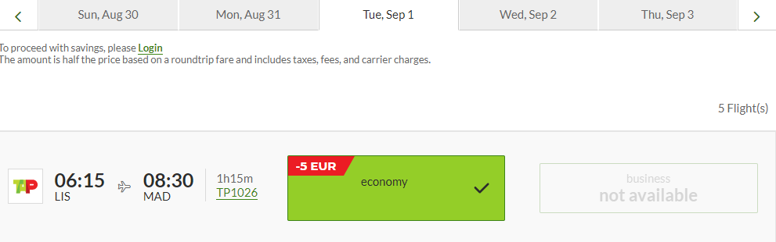

- After flight’ selection, an option to redeem a voucher is displayed, same page below.

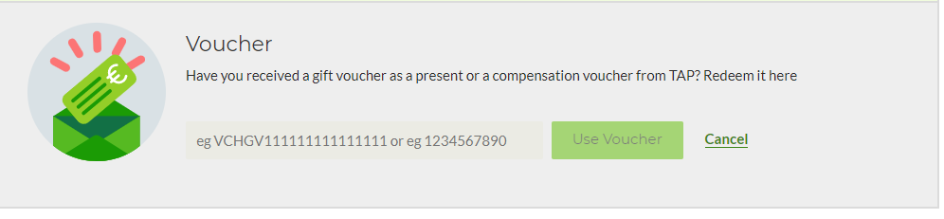
2.1- this option is also displayed as Primary Passenger Details are inserted

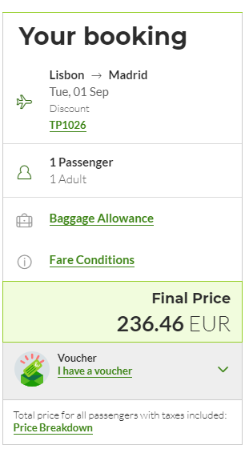

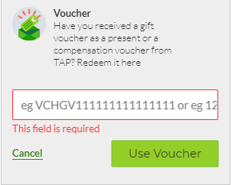
If voucher amount does not cover ticket’s total amount, one additional form of payment can be added (only one voucher can be used as form of payment in one online booking).
Note: vouchers’ currency must be the same as the one applied in new booking.

